Exercise

a) Get Order id, Product id, Unit price from Order Details.

Solution:

use Northwind;

select OrderID, ProductID, UnitPrice from [Order Details]

Output:

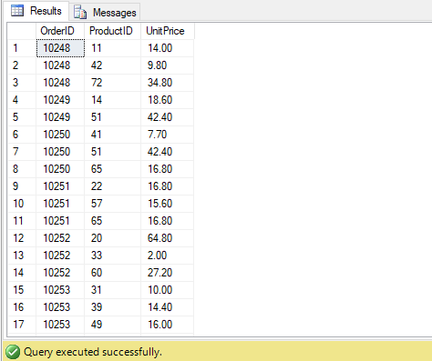

b) Get the price of an order (by multiplying unit price by quantity).

Solution:

use Northwind;

select UnitPrice*Quantity [Price] from [Order Details];

Output:

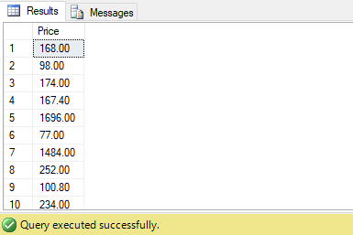

c) Display all cities that employees belong to but don’t allow repetition.

Solution:

use Northwind;

select*from Employees where City in ('London','Seattle','Redmond');

Output:

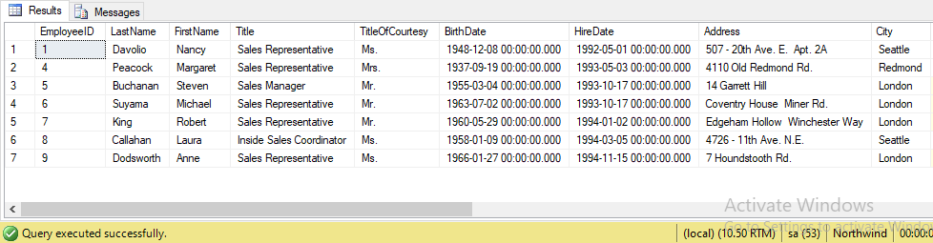

d) Find complete name of all employees.

Solution:

Select FirstName+ + LastName [Full Name] from Employees;

Output:

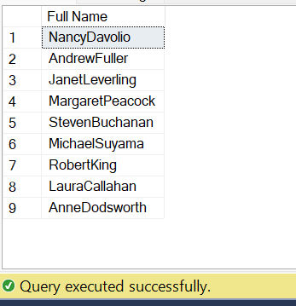

e) Display data of all employees those working as Sales Representative.

Solution:

Select * from Employees where Title = 'Sales Representative';

Output:

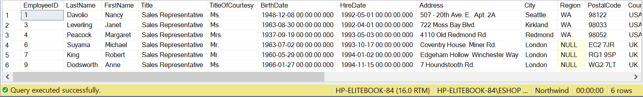

f) Display complete name of employees those lives in London.

Solution:

Select FirstName+ +LastName [Full Name] from Employees where City in ('London');

Output:

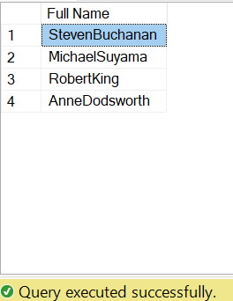

g) Display product name whose unit price are greater than 90$.

Solution:

Select ProductName,UnitPrice From Products where UnitPrice>90;

Output:

h) List the name of all employees whose first name starts with the letter ‘A’..

Solution:

Select FirstName from Employees where FirstName like 'A%';

Output:

I)Display names of all employees whose name contain ‘an’.

Solution:

select * from Employees where FirstName Like '%an%';

Output:

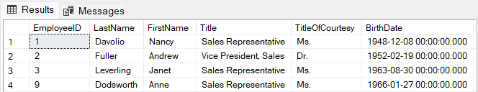

j) Display the company name where Region is NULL in Customer Table.

Solution:

Select CompanyName from Customers where Region is Null;

Output:

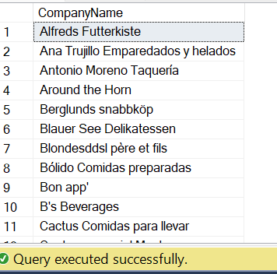

k) Write a query to list employees who live in London, Seattle or Redmond

Solution:

Select * from Employees where City in ('London','Seattle', 'Redmond');

Output:

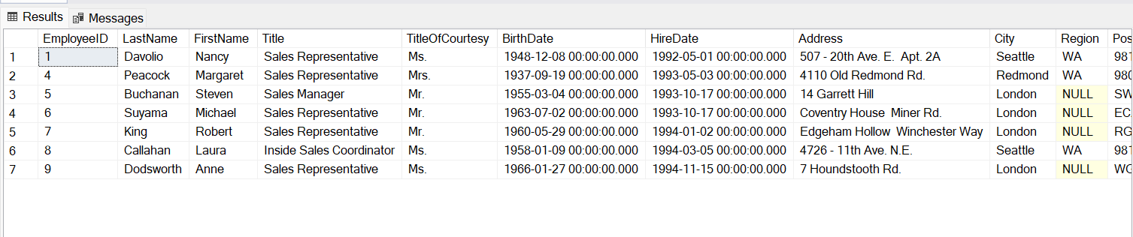

L) Write a query to list employees whose address contains 3 numbers in its start.

Solution:

Select * from Employees where Address like '[0-9][0-9][0-9]%';

Output:

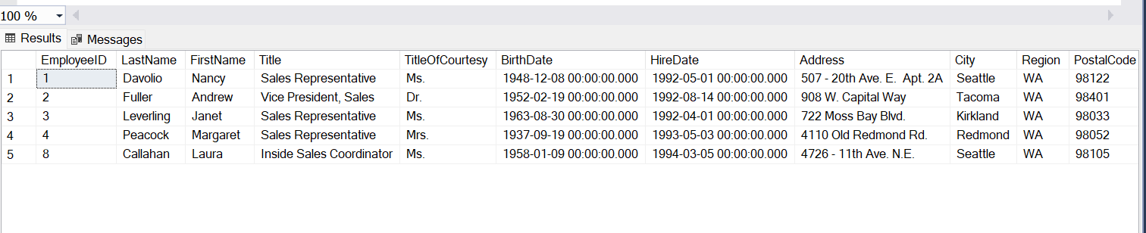

m) Write a query to list those employees whose TitleofCourtesy does not starts with M.

Solution:

Select * From Employees where TitleOfCourtesy not like 'M%';

Output:



n) List all products where UnitPrice is between 10 and 15 and QuantityPerUnit contains “bottles”.

Solution:

Select ProductName,QuantityPerUnit from Products where UnitPrice between 10 and 15 and QuantityPerUnit like '%bottles%';

Output:

o) List all products where UnitPrice is not in 10,12,15,17 or 19.

Solution:

Select * from Products where UnitPrice not in (10,12,15,17,19);

Output:

